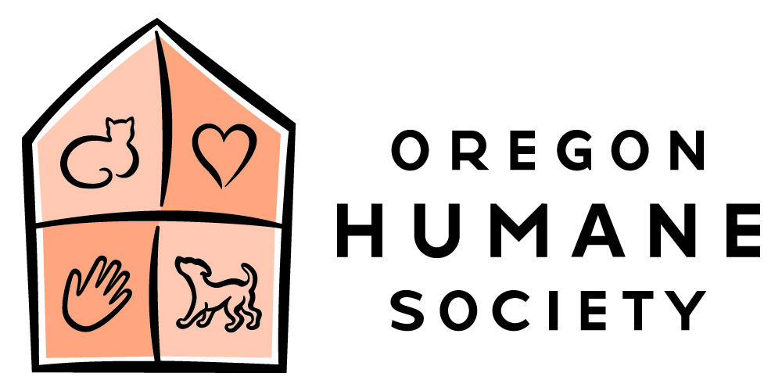

Social Distancing Policy

Oregon Humane Society will operate in accordance with Oregon requirements and CDC recommendations to prevent the spread of COVID-19. To serve our community, we are required make robust plans which meet social distancing requirements—and to strictly enforce those requirements with designated individuals charged with ensuring compliance.

For employees this means that telework options are available to staff whenever possible and appropriate for their jobs unless and until OHS specifically requests staff to return onsite as the shelter reopens for business. Social distancing measures at the shelter consistent with guidance from the Oregon Health Authority and the CDC will be enforced. This means maintaining 6 feet between individuals and use of protective personal equipment. Masks must be worn by staff, volunteers and guests. Those that do not have a mask will be provided one. Gloves/gowns will be required if appropriate to the work.

- If you are working alone in a space with no contact with others, you are not be required to wear a mask during that time
- If you are eating your lunch, be sure to maintain your distance while your mask is down
- Masks should cover your nose and mouth
- Cloth masks should be washes and dried daily
- Make sure to wash your hands before putting a mask on or off to protect the sanitation of your face covering

Areas of social interaction such as break rooms, bathrooms, locker rooms etc. have posted occupancy limits. Every effort will be made to limit unnecessary overlap in schedules and workspaces. Please also continue rigorous personal protection practices of frequent hand washing, work area sanitation, cough or sneeze into disposable tissues etc. We should all be aware and support each other in maintaining our distance and adhering to OHS policy and CDC guidelines. Managers will monitor our work areas to ensure our compliance.

If you are reminded about any safety precautions, please thank that individual and know we are all working together to keep each other and our workplace safe. These strictly observed measures allow OHS to remain in operation serving animals, preserving jobs and protecting employee and public health.

